Lesson 5 Demo 18: Troubleshoot a Service Which Is Unable to Deploy

This section will guide you to:

* Troubleshoot a Docker service which is unable to deploy

**Step 1:** Troubleshoot the running services

* Use the following command to list all the services running in the swarm:

*sudo docker service ls*

**Note:** Check whether all the replicas for a service are actually running

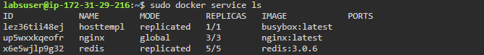

* Use the following command to inspect the *redis* service for configurations:

*sudo docker service inspect redis*

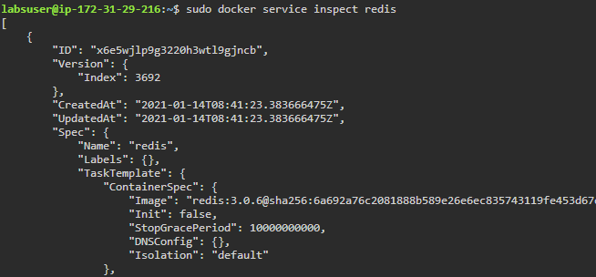

**Step 2:** Troubleshoot the tasks assigned for the *redis* service

* List the tasks assigned for a given service to determine whether they are currently running or not

*sudo docker service ps redis*

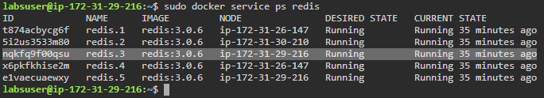

**Note:** Make sure you pick the task running on that specific node. In this case, tasks **redis.3 and redis.5** running on **manager** node can be inspected on this node only. For inspecting other tasks, you need to move to the **worker1** or **worker2** nodes.

* Use the following command to install **jq** package:

*sudo apt install jq*

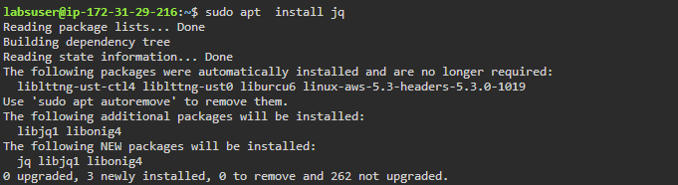

* Use the following command to inspect a specific task to determine which container is associated with the given service:

*sudo docker inspect TASK_ID | jq -r* \

'*.[].Status.ContainerStatus.ContainerID*'

***Note:*** *Replace TASK_ID with the Id of a selected task. In this case Task Id is nqkfq9f00qsu*

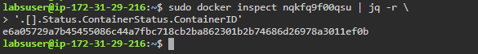

**Step 3:** Troubleshoot the container associated with the *redis* service

* Use the following command to get the container state:

*sudo docker inspect CONTAINER_ID | jq '.[].State'*

***Note:*** *Replace CONTAINER_ID with the first 12 characters of container Id received in the previous step. In this case, the Container Id is bf2c4982d71a.*

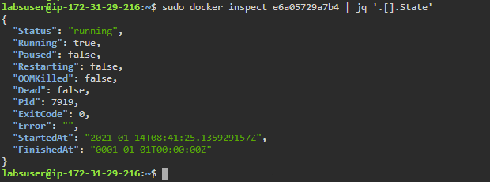

**Note:** **ExitCode** and **Error** show the reasons why a container has made an exit

* Use the following command to check the *Network Settings* of the container:

*sudo docker inspect CONTAINER_ID | jq '.[].NetworkSettings'*

***Note:*** *Replace CONTAINER_ID with the first 12 characters of container Id received in the previous step. In this case the Container Id is bf2c4982d71a.*

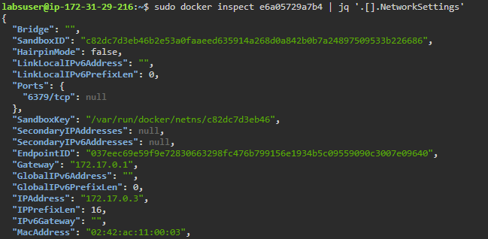

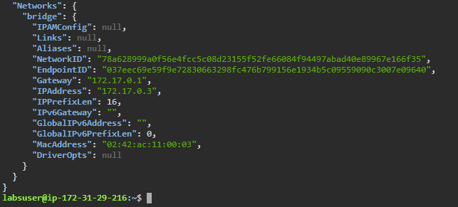

* Use the following command to get detailed **logs**of *redis* service:

*sudo docker service logs redis*

